**Recent progress in low noise coherent supercontinuum generation in silica and tellurite all-normal dispersion fibers**

T. Sylvestre1, E. Genier2, P. Bowen2, S. Rao DS3, T. Karpate4, M. Klimczak4,

R. Buczyński4, J. M. Dudley1, and O. Bang2,3

1:Institut FEMTO-ST,UMR6174 CNRS-Université Bourgogne Franche-Comté, 25030 Besançon, France

*2: NKT Photonics A/S, Blokken 84, DK-3460, Birkerød, Denmark*

*3: DTU Fotonik, Department of Photonics Engineering, Technical University of Denmark, Lyngby*

*4: Faculty of Physics, University of Warsaw and Łukasiewicz Research Network, Warsaw, Poland*

Email: thibaut.sylvestre@univ-fcomte.fr

**Abstract:** We review our recent works on coherent supercontinuum generation in all-normal dispersion photonic crystal fibers and demonstrate ultra-flat octave-spanning coherent spectra with ultra-low noise and polarization properties. These new broadband fiber sources could find applications in biomedical imaging and metrology, where the signal-to-noise ratio is essential.

Supercontinuum (SC) generation in all-normal dispersion (ANDi) photonic crystal fibers (PCFs) has recently been investigated due to its ability to generate a low-noise broadband coherent spectrum, with a noise level much lower than typical soliton-based SC sources based on anomalous dispersion fibers [1,2]. ANDi SC generation, which is essentially based on self-phase modulation (SPM) and optical wave breaking (OWB), has a high degree of coherence and high pulse to pulse stability [1,2]. Here we review our recent works towards ultra-stable and flat SC generation using silica and tellurite-glass ANDi PCFs [2,3]. We report an ultra-flat octave-spanning (670 nm-1390 nm) coherent SC with excellent low noise (relative intensity noise RIN<0.54 %) and polarization (PER>17 dB) properties in silica PCFs (See Figs.1a-b). This was achieved using a polarization-maintaining (PM) ANDi PCF pumped by a compact ytterbium-doped femtosecond laser at 1049 nm.

Shot-shot SC noise has also been studied in both PM and non-PM ANDi tellurite PCFs using dispersive Fourier transformation (DFT) [3], with experimental results well-reproduced by vector and scalar GNLSE numerical simulations. By comparing the RIN in the PM and non-PM fibers, supported by simulations, we demonstrate the advantage of the PM property and we associate the low noise with the suppression of polarization modulation instability.

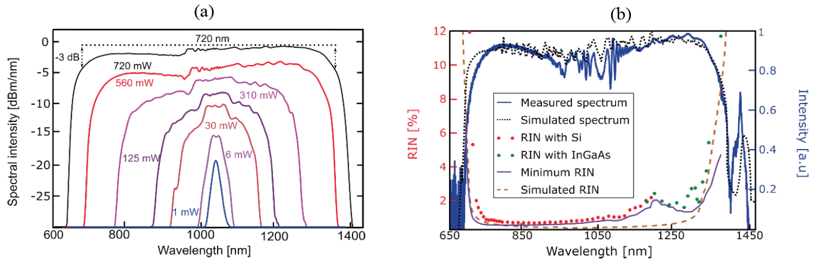

Figure 1 : (a) Experimental SC spectra generated in the PM-ANDi silica PCF for an average power from 1 mW to 720 mW with an input pulse duration of 180 fs and an input beam polarized along the fast axis. (b) RIN measurements using a silicon (red dots) and an InGaAs (green dots) photodetector and an oscilloscope, and corresponding average normalized SC spectrum (solid blue),

pumping at 45° from the fiber principal axes at maximum power. Simulated SC (black dots) and RIN spectra (dashed brown).

References

[1] A. M. Heidt, A. Hartung, G. W. Bosman, P. Krok, E. G. Rohwer, H. Schwoerer, and H. Bartelt, "Coherent octave spanning near-infrared and visible supercontinuum generation in all-normal dispersion photonic crystal fibers," Opt. Express **19**, 3775-3787 (2011).

[2] E. Genier, S. Grelet, R. D. Engelsholm, P. Bowen, P. M. Moselund, O. Bang, J. M. Dudley, and T. Sylvestre, "Ultra-flat, low-noise, and linearly polarized fiber supercontinuum source covering 670–1390 nm," Opt. Lett. **46**, 1820-1823 (2021)

[3] S. Rao D. S., T. Karpate, A. N. Ghosh, I. B. Gonzalo, M. Klimczak, D. Pysz, R. Buczyński, C. Billet, O. Bang, J. M. Dudley, and T. Sylvestre, "Noise in supercontinuum generated using PM and non-PM tellurite glass all-normal dispersion fibers," Opt. Lett. **47**, 2550-2553 (2022).